nmCollector.net LLC

NM Collector CP 2.3 User Manual

Table of Contents

Table of Contents ii
Introduction 1
References 1
General Concepts 2
Collection Templates 2
Available Field Types 2
Operating Systems 3
Mobile Apps 3
Acquisition and Activation 3
Installation and Startup 3
USB Flash Drive 4
USB File Structure: 4
USB Instructions: 4
Windows 4
Installation 4
Startup 4
Mac (Intel and Apple Silicon) 4
Installation 4
Startup 4
Linux 5
Installation 5
Startup 5
Operation 6
Main Page 6
Title Bar 6
Menu Bar 6
Collection Drop Down 7
Add (Item) Button 7
Sort (Item) Button 7
Filter (Search) Field 7
Stats Button 7
Print Button 7
List of Items 7
Statistics Page 8
Reports 9
Canned Reports 9
Custom Reports Feature 10
Print Page Report Buttons 12
ID Page 13
Duplicate (Item) Button 13
Move (Item) Button 13
Delete (Item) Button 13
Print Button 13
Fields 13
Autocomplete and searchable choices 14
Desktop instructions 14
Android and iOS instructions 14
Coverage and field controls 14
Edit Drop Down List (DDL) Page 15
Description Page 17
Pictures Page 18
Add (Picture) Button 19
Drag and Drop Picture 19
Remove (Picture) Button 19
Picture Scroll Bar 19
Picture Display Options 19
Receipt Page 20
Disposition Page 21
Related Items Page 22
Add Related Item Page 23
Maintenance Page 24
Duplicate (Maintenance) Button 24
Add (Maintenance) Button 24
Remove (Maintenance) Button 24
Maintenance Scroll Bar 24
Events Page 26
Data Sheet Page 27
Links Page 28
Add (Link) Button 28
Add Link Page 29
Drag and Drop Link 29
Export Menu 30
Current Collection Template 30
Current Collection Items to CSV 31
Export To Data Transfer 31
Import Menu 31
Collection Template 32
Items From CSV 33
From Data Transfer 33
Reports Menu 33
Backup Database Menu 34
Recover Database Menu 34
Clear Database Menu 35
Edit Menu 35
Edit Collections 36
Edit Collection Templates 37
Edit Tab Labels 38
Options Enable/Disable Backups 38
Activation Menu 39
Help > About Menu 39
About Page 40
Support 40
Companion Apps 41
General 41
iOS 41
Android 42
NM Collector CP Software Version History 42
Version 2.3 Released October 2026 42
Version 2.2 Released April 2023 43
Version 2.1 Released March 2023 43
Version 2.0 Released November 2021 43
Version 1.0 Released October 2021 44
Version 0.7 Released October 2021 44
Version 0.6 Released September 2021 44
Version 0.5 Released August 2021 44
Version 0.4 Released July 2021 44
Version 0.3 Released July 2021 45
Version 0.2 Released June 2021 45
Version 0.1 Released May 2021 45

Introduction
Software developed by collectors for collectors.
n
mCollector.net LLC has been developing collector software for over two decades. NM Collector CP software is the latest edition in a line of successful packages used by individual collectors to track and manage their collections. Our intent is to keep NM Collector CP relevant and up to date for the foreseeable future so it will be the last edition you will ever need.
This manual is a complete description of the software with detailed operating instructions. It is formatted such that it can be printed and placed in a binder for those who like to have paper copies of documents. The latest version of this user manual and other sources of information including our blog and our support pages can be found at www.nmcollector.net
References
Some useful resources can be found on these pages.
- Our ecommerce site can be found at: www.nmcollector.net
- Lots of usage hints and information at: https://www.nmcollector.net/blog
- NM Collector Software Support: https://www.nmcollector.net/support

General Concepts
Manage any collection on any platform.
T
his software provides flexibility for you to manage any type of collection using the terminology and content that you want to use. Defaults are provided for many types of collections which can be used as is or modified to suit your preferences.

Collection Templates
Collection templates are used to manage captions that appear on the pages. Values can be changed as needed. Values that appear in dropdowns can also be modified. New templates can be created from scratch or from an existing template.
NM Collector CP comes with twenty-nine ready-made collections: Ammo, Art and Antiques, Books, Cameras and Lenses, Coins, Firearms, Fishing Tackle, Geological, Home Inventory, Knives, Licenses, Militaria, Motor Vehicles, Musical Instruments, Nihonto (Japanese swords), Paper Items, Pens and Writing Instruments, Radios and Electronics, Recipes, Records and Media, Southwest Pottery and Jewelry, Sports Cards and Memorabilia, Stamps, Subscriptions, Tools and Shop Equipment, Toys and Models, Watches and Clocks, Whistles, and Wine and Spirits.
Each collection has drop-down lists of common values for its fields and three sample items that show how the fields are meant to be filled in. In each template, the Identification tab holds what tells one item apart from every other, and the Description tab holds condition, storage, provenance and value.
Collection templates can also be downloaded from www.nmcollector.net/downloads and added with [File > Import > Collection Template]. See Import Menu for what an import does to a collection you already have.

Available Field Types
Data is captured in a variety of field types.
- Drop-down fields capture text using a list of reusable choices. On Windows, Mac and Linux, autocomplete filters suggestions as you type. On Android, iPhone and iPad, tap a field to open a searchable picker. Select an existing value or explicitly save a new one. See Autocomplete and searchable choices in the ID Page section for step-by-step instructions.
- Number fields capture any numbers relevant to the item. Formatting is not applied because a number field can be used for any number (pun intended) of formats.
- Date fields are used to capture important dates.
- Notes fields allow you to capture larger amounts of text.

Operating Systems
This collection management software can be run on Windows, Mac, and Linux. It can be run from a USB flash drive but the data will be stored on the system in which the USB is plugged into. Data can be exported from one platform and imported into the other.

Mobile Apps
Companion mobile apps are available for iOS and Android devices. Data can be transferred between devices. See Android and iOS sections below for more details. Editable dropdowns on phones and tablets use searchable pickers, with a larger selection area and explicit actions for selecting or adding a value.

Acquisition and Activation
This software is available via download or can be delivered on a USB flash drive. The download provides a full featured 30 day evaluation period. After that it will convert to a free version with fewer features. The full feature version can be activated with the purchase of an annual subscription. The USB option can only be purchased with a subscription.
NOTES:
- When the 30-day evaluation expires and the software reverts to the free version, data will not be lost and will become available again after the purchase of a subscription to activate the full features.
- You can export all of your data even after the subscription has expired so you are not locked in if you ever decide not to renew your activation.
Installation and Startup
Installation and startup depend on the operating system.
O
nce downloaded, you must decide how you want to run the software. The specific options and procedures depend on the operating system as referenced below.

USB Flash Drive

USB File Structure:

- NMCollectorCP_Win_2.3.0.zip
- NMCollectorCP_Mac_Intel_2.3.0.zip
- NMCollectorCP_Mac_AppleSilicon_2.3.0.zip
- NMCollectorCP_Linux_2.3.0.zip
- USB Instructions

USB Instructions:

This USB flash drive contains NM Collector Software CP deployments for Windows, Mac, and Linux operating systems. Each deployment is contained in a zip file. There is also an activation file that is used to activate the software. The activation time period depends on the purchase option you chose. Please use [Activation > Apply] and navigate to the activation.lic file included on the USB Flash Drive to apply your activation to your copy of NM Collector Software.

Copy the zip file for your operating system to your computer, extract its contents, and follow the instructions for your operating system below. Each zip file also contains an Instructions text file for that operating system.

Windows

Installation
Open the installer folder and run Setup NMCollectorCP.exe. Follow the prompts. You can choose to create a desktop shortcut.

Startup
Start NM Collector CP from the Windows Start menu, or from the desktop shortcut if you created one.

Mac (Intel and Apple Silicon)

Installation
Use the zip file that matches your Mac: NMCollectorCP_Mac_Intel_2.3.0.zip for an Intel Mac, or NMCollectorCP_Mac_AppleSilicon_2.3.0.zip for an Apple Silicon (M-series) Mac. Open the installer folder and double-click NMCollectorCP.dmg to open it, then drag NM Collector CP into your Applications folder.

Startup
Start NM Collector CP from your Applications folder.

Linux

Installation
- Extract the contents of NMCollectorCP_Linux_2.3.0.zip to a folder on your computer.
- Do not extract the files to a USB flash drive on a Linux system. This causes errors.
- This creates the NMCollectorCP_Linux directory, which contains the application.
- For reports to work, you must also install Microsoft fonts (Arial in particular).
NOTE: Please follow the instructions found here: https://lexics.github.io/installing-ms-fonts

Startup
- Open a Terminal window in the NMCollectorCP_Linux directory
Option 1 :
  - From desktop, navigate to the NMCollectorCP_Linux folder,
  - right click on it and
  - select "Open in terminal" from the dropdown list
Option 2:
  - Open a Terminal window
  - cd to the NMCollectorCP_Linux directory
- Start the NMCollectorCP application from the Terminal Window with:
sh run.command

Operation
Operation is consistent across all operating systems.
L
inux will have some minor variations but, other than that, the features and operation are the same across all desktop operating systems. Companion mobile apps are generally consistent but have some differences.

Main Page

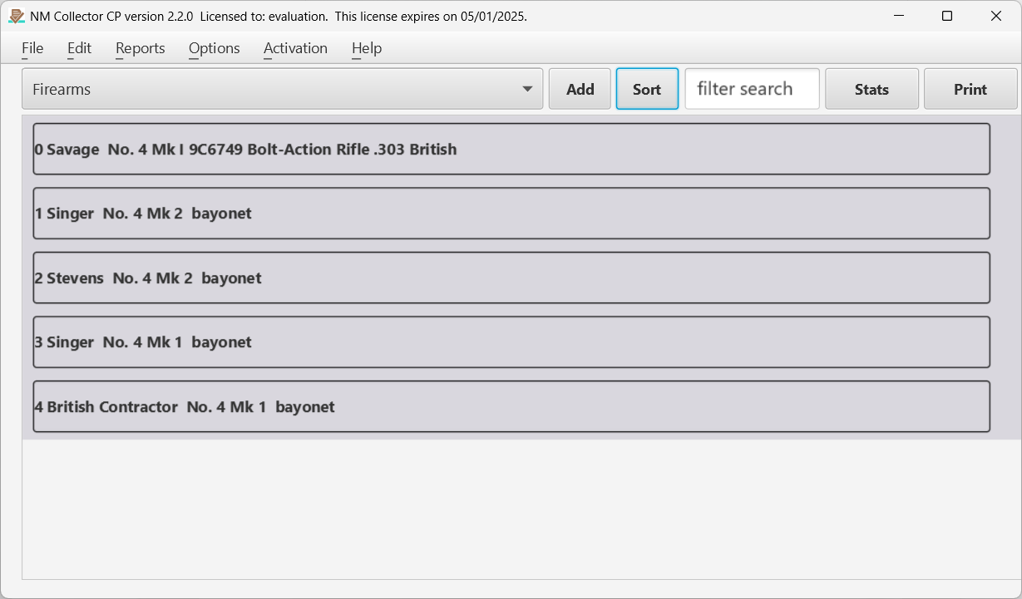
Figure 1 The Main page of the application where items are listed.
This page is the center of control of the application. The collection is selected from the drop down and items for that collection are listed on the page. Clicking on an item in the list will take you to the data for that item.

Title Bar
The title bar contains the name of the application, the current version you are running, and the subscription (activation) expiration date.

Menu Bar
The menu bar gives you access to reports, file functions, edit features, options, activation (subscription), and help.

Collection Drop Down
The collection drop down contains a list of the available collections. Selecting a collection loads the template for that collection and the list of items in that collection.

Add (Item) Button
This button adds a new item to the selected collection and opens the identification tab for you to enter key values for identifying this new item .

Sort (Item) Button
This will change the sort order of the items displayed between ascending and descending.

Filter (Search) Field
Enter values in this field to filter what items are displayed. Only items that match the filter will be displayed. Click the check mark displayed in the field or hit return to apply the filter. Click the X displayed in the field to clear the filter.

Stats Button
Clicking this button will open the statistics page where data is displayed in a table format and summaries are calculated. Please see the statistics description below.

Print Button
This button opens a printable report containing the currently listed items. If the list is filtered then only those filtered items will show up in the report.

List of Items
The rest of the page consists of a list of items in the collection. Clicking on an item in the list takes you to the Identification (ID) tab for that item. Other tabs also become available. Each of these tabs is covered below.

Statistics Page

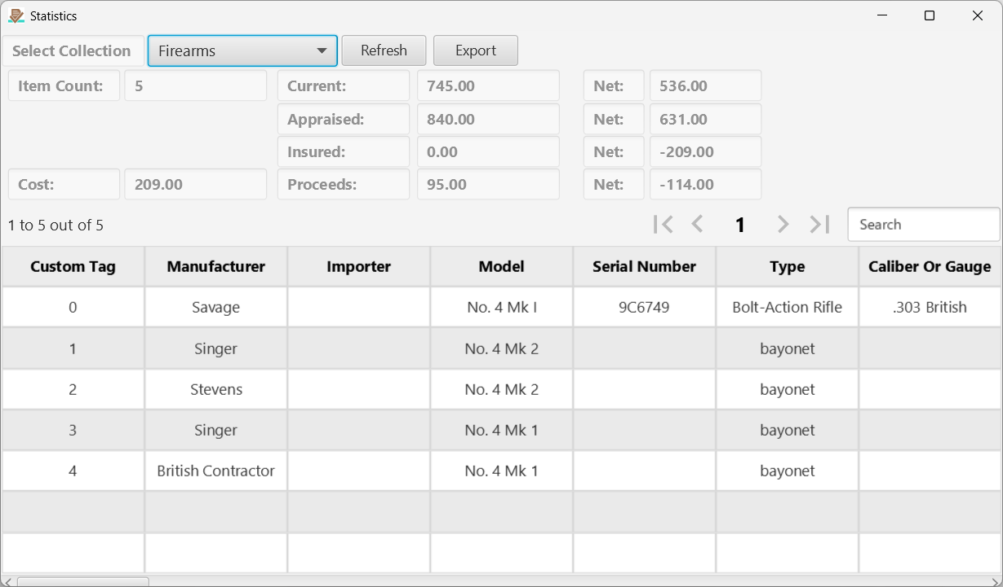
Figure 2 The Statistics page.
Clicking the Stats button on the Main page opens this page which displays a complete list of values and some stats for the selected collection. Click on a header to change the sort order of the data. Click a row to open the ID page for the clicked item.
Hint: Use the Search field to quickly find items on the page. In fact, for very large collections, it is faster to jump directly to this statistics page to find items of interest than to wait for all of the items to load on the main page.

Reports

Canned Reports

Note: These are not available in mobile apps.
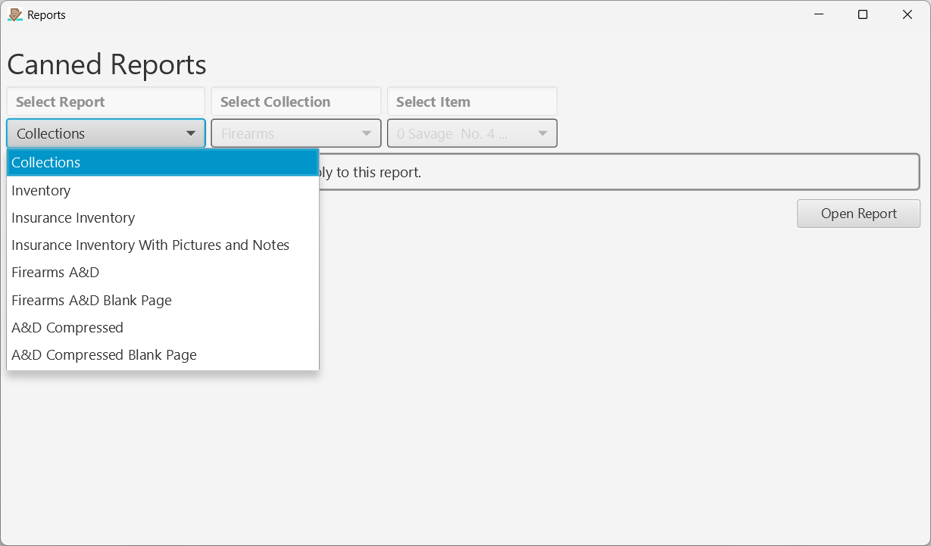
Figure 3.A The Canned Reports page.
Clicking [Reports > Canned] from the Main page menu opens this page which provides an interface for selecting from available predefined reports. The Select Collection and Select Item drop downs are enabled and disabled depending on what report you select.
If you are handy with Jasper Reports you can develop your own predefined canned reports as well.

Custom Reports Feature

Note: These are not available in mobile apps.
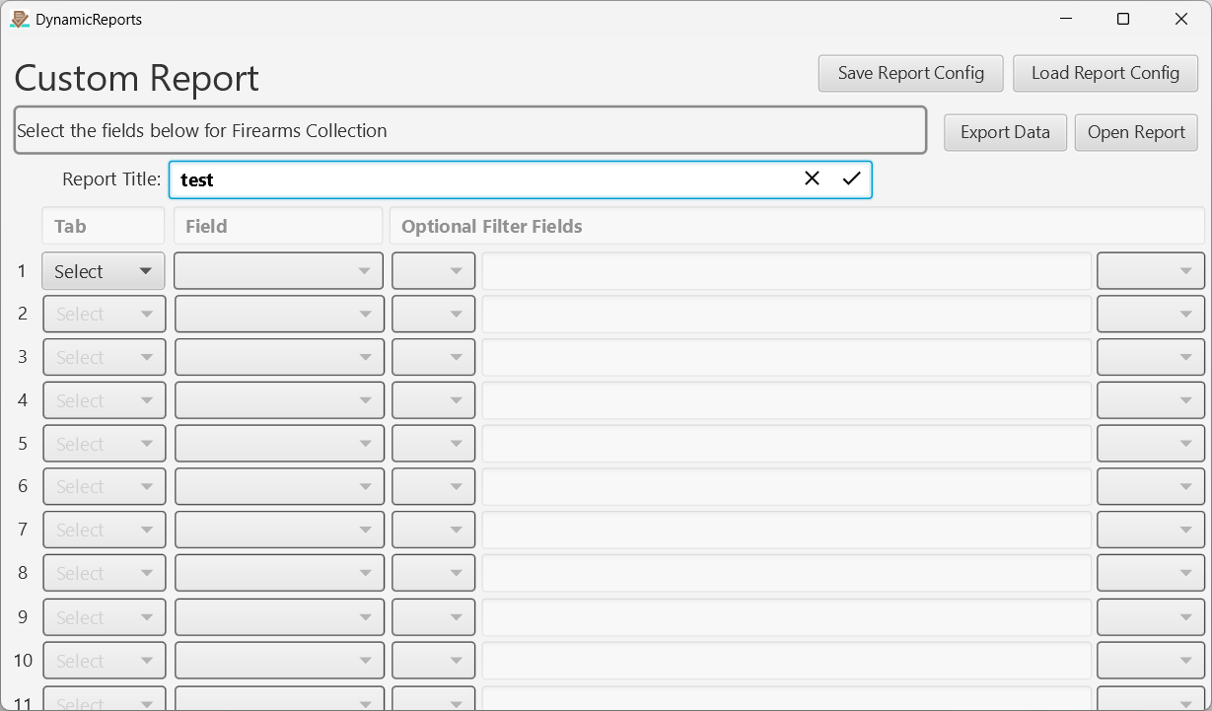
Figure 3.B The Custom Reports page.
Clicking [Reports > Custom] from the Main page menu opens this feature which allows you to select fields that you want to display in a report. Once you have defined a report configuration you click the [Open Report] button to display it.
Unlike the canned reports, these are dynamically generated so they cannot be predefined in Jasper Reports. Instead, an HTML file of the report named dynamicReport.html is generated and stored on your local file system in your NM Collector CP data reports directory (see [Help > About] for that directory location on your system). It is then opened for display and print by your default web browser.
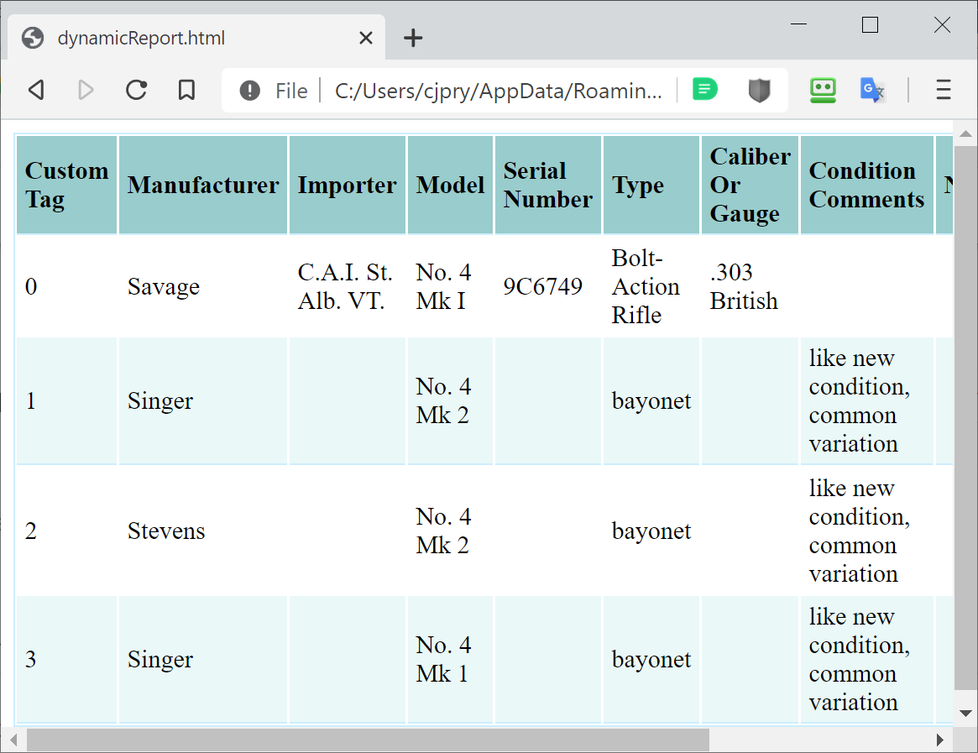
Figure 3.C Sample Custom Report
You can also save your report configuration with the [Save Report Config] button. It will be saved in a file named with the report title you entered and extension of .rept in the location (directory) you choose. You can load it using the [Load Report Config] button. This saves you from having to re-enter the criteria every time you want to load the same report.
You can optionally filter those fields to limit results that appear in the report. This can get a little complicated and produce unexpected results if you add too many options. Here are some suggestions:
- It is best to add filters to the end if you will have multiple filters.
- If an item is missing from a report, it could be that you added a field for a record that does not yet exist. For example, if you want to see the receipt date but no receipt has been entered you will not see the item that has no receipt date.
- When there is more than one filter the default is to use AND conjunctions.
- OR conjunctions can produce unexpected results.
- You cannot use comparison operators (=, !=, >, <) on dates.
- != means “Not Equal”

Print Page Report Buttons

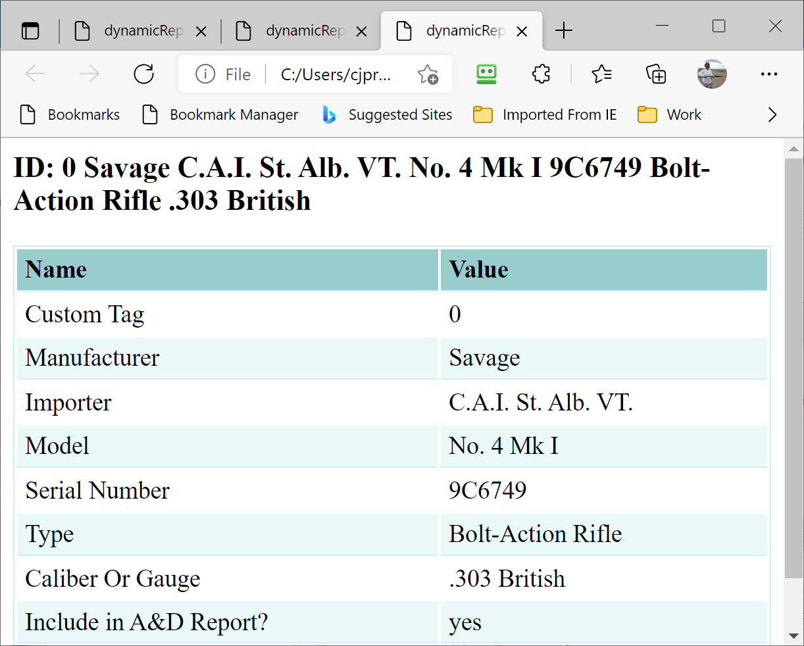
Figure 3.D Print Button for Identification Tab
A Print button can be found on many tabs. When clicked it will open a printable report for that tab. The Print Page Report is generated dynamically, like the Custom Reports feature, and displayed in your web browser.
Note: On Android, the Print button opens a chooser so you can send the report to Gmail, Google Drive or any other app. On iOS, save the report to your file system and then open it from there.

ID Page

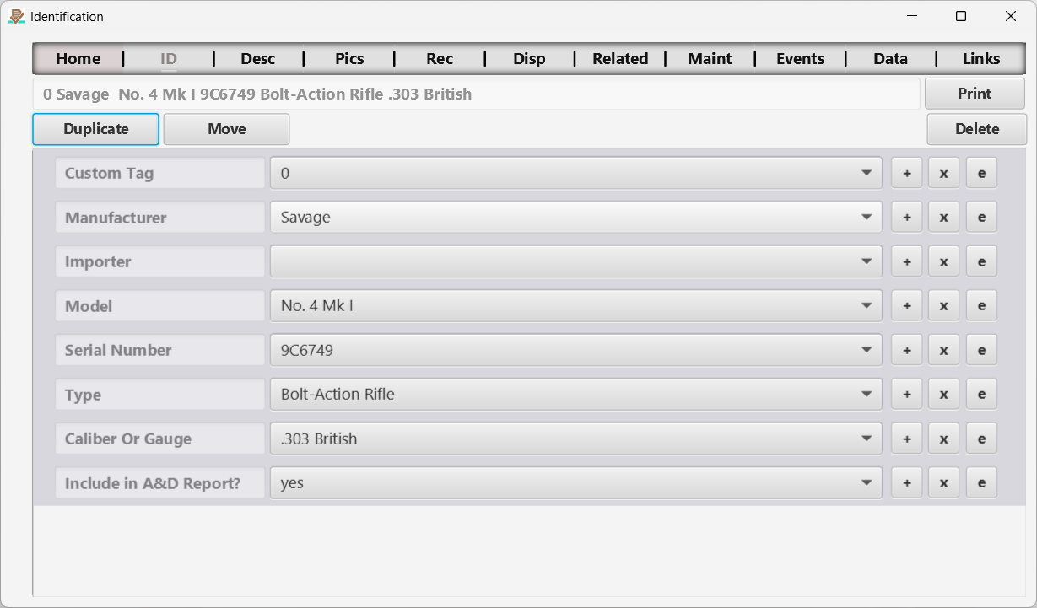
Figure 4 The Identification page.
This page is the center of control for an individual item. Not only does it display key identification information, but it also provides buttons for duplicating, deleting, and even moving an item from one collection to another.

Duplicate (Item) Button
This feature will replicate the current item’s identification, description, and receipt information a selected number of times. This is useful for entry of multiple similar items.

Move (Item) Button
You can move an item from one collection to another with this feature.

Delete (Item) Button
After confirmation, this deletes the current item from the database, together with its picture records and notes. Picture files are not deleted from the Picture Path.

Print Button
Prints currently displayed data. See reports section of this manual.

Fields
The remaining ID fields capture information about the item. Editable drop-down fields support autocomplete on desktop and searchable pickers on mobile. The same behavior applies to Description, Receipt, Disposition, Pictures metadata, Maintenance and Events. Tab labels and field captions can differ by collection. The +, x and e buttons appear beside each drop-down field.

Autocomplete and searchable choices
Use these controls to find a choice without scrolling through a long list. Searches ignore capitalization and match text anywhere in a value. For example, typing part of a manufacturer name narrows the list to matching manufacturers. Each field uses the choices for its own collection and tab.

Desktop instructions
1. Click the editable text/drop-down field. Select the existing text if you want to replace it, then type all or part of the value you need. Matching suggestions appear as you type.
2. Click a suggestion to save it, or use the Up and Down arrow keys to highlight a suggestion and press Enter. The drop-down arrow opens the available choices without requiring a search.
3. To save a new value, type it and press Enter with no suggestion highlighted. If an existing choice matches the text apart from capitalization, the existing spelling is used. Otherwise the new nonempty value is saved and added to this field’s reusable choices.
Cancel unfinished typing. Press Escape, press Tab or leave the field to discard an uncommitted edit. Selecting a suggestion or pressing Enter commits the value immediately; cancelling afterward does not undo a value already saved.

Android and iOS instructions
1. Tap the value area of an editable field. A searchable list opens. You can browse without typing; the current nonempty value appears first and is marked with a check.
2. Tap the search field and type to narrow the choices, then tap a result to save it and return to the item. An existing selected value keeps its stored text.
3. To create a new value, type it and tap Use new value. This action saves the entry and adds it to the field’s reusable choices. Leading and trailing spaces are removed from new entries. If the text exactly matches an existing choice, select that result instead.
Cancel without saving. Tap Cancel or use navigation Back to return without changing the original value. Typing, hiding the keyboard and pressing its Done or Return key do not save. On Android, the first Back press may dismiss the keyboard; another Back press closes the picker.
Phones and tablets. The picker uses the available phone width and a centered panel on larger tablet screens. Its result area adjusts when the keyboard opens. On shorter screens, Use new value moves into the header. Android retains portrait orientation; iPhone and iPad support the orientations available in the app.

Coverage and field controls
Autocomplete and searchable pickers apply to editable text/drop-down fields on the seven tabs listed above. Number, date and note fields use their own input controls. Picture paths are read-only. Collection selectors, report selectors and other navigation controls do not use autocomplete.
Large lists. At most 200 matching choices are displayed at once. Type more of the value to narrow a longer list; filtering searches the full set of choices. If there is no match, refine the search or explicitly save a new value.
Pictures, Maintenance and Events can contain several records for one item. Check the current picture or record before opening a field. Saving applies the value to that record. On mobile, returning from the picker keeps you on the same record and preserves your place on the page.
The buttons beside each drop-down field provide the following actions:
- +
The + button adds a reusable choice to this field’s drop-down list. You can also add a new value while editing, through desktop autocomplete or the mobile Use new value action described above.
- x
The x button immediately saves an empty value for the current field. Clearing an item’s field does not remove the old value from its reusable drop-down list. Use e to manage those choices.
- e
The e button opens the Edit Drop Down List (DDL) Page, where you can edit or remove reusable choices for the selected field. It does not open the autocomplete search.

Edit Drop Down List (DDL) Page

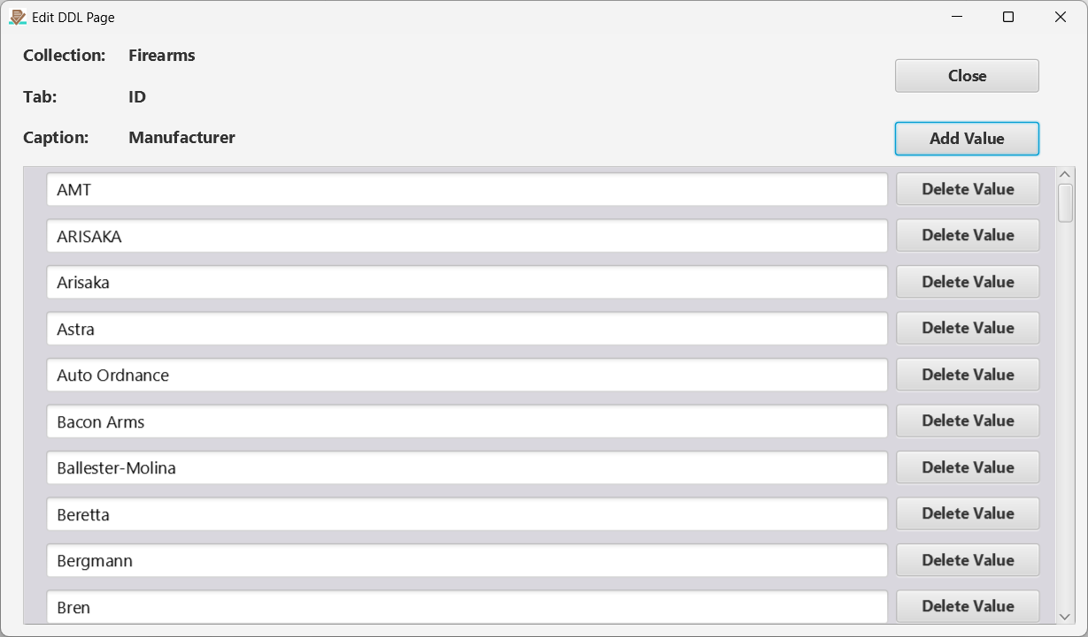
Figure 5 The Edit Drop-down List page.
This page manages the reusable choices for the selected field. The autocomplete suggestions and mobile picker use that field’s drop-down list. A value already saved on an item may still be shown as its current value even if it is absent from the list. Explicitly saving that value through autocomplete or the picker adds it back to the list. To clear the value from the current item or record, use the x button beside the field.

Description Page

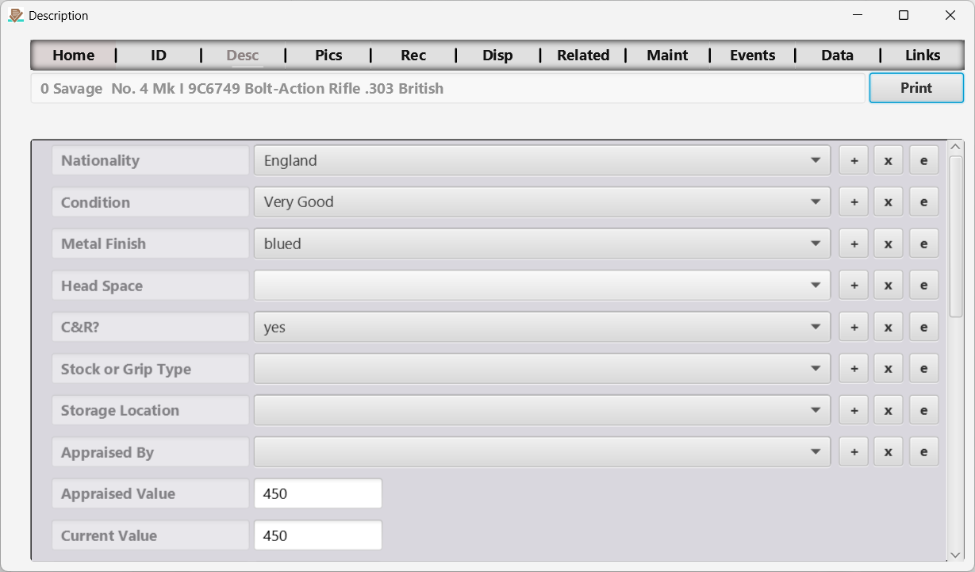
Figure 6 The Description page.
Here description information can be captured. It can be difficult at times to distinguish between identification and description information. I like to think of identification information as that which uniquely identifies the item. Description information is not required to uniquely identify the item. You can decide what fields you consider to be identification and description by customizing your collection template to suit your needs.
Editable text/drop-down fields on this page use the same desktop autocomplete and mobile searchable picker described under Autocomplete and searchable choices in the ID Page section.

Pictures Page

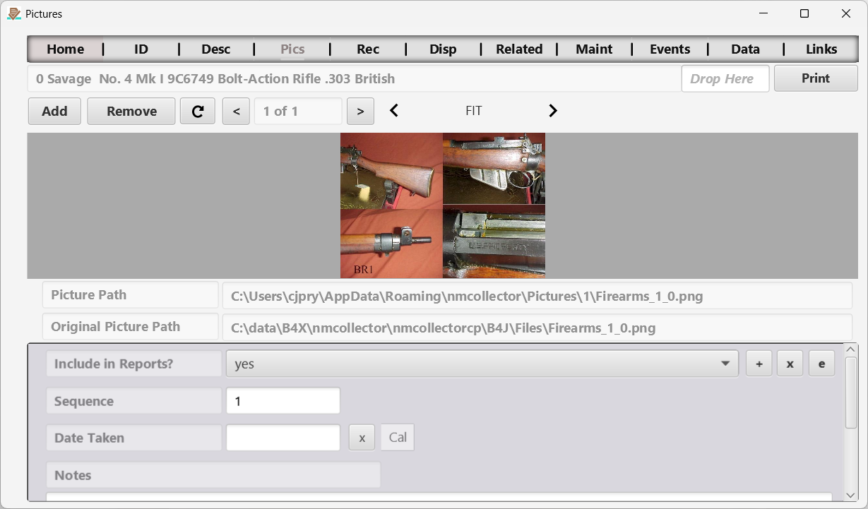
Figure 7 The Pictures page.
Capture one or more pictures and associated data for the selected item.
Use autocomplete or the mobile searchable picker for editable picture metadata. On mobile, switch to Meta Data to reach these fields. The picture path and original path are read-only. A selection changes the currently displayed picture’s metadata, and returning from the mobile picker keeps that picture selected.
NOTES:
- A primary objective is to preserve your data.
  - When you remove a picture from an item, that picture is not deleted from the Picture Path. It is just removed from the database for that item.
  - If you try to add a new picture that has the same name as a current picture for that item stored in the Picture Path, the old picture will not be replaced by the new picture. If you want to remove the old picture you must manually delete it from the file system.
- If you copy the database from one system to another the pictures will not load unless they are also manually copied to the specified Picture Path. This will not work if you copy from one operating system to another. For example, copy from Windows to Linux will not work because the paths will be a different format.
- Better to export (discussed elsewhere) your data from one system and then import it into the other. This will transfer the pictures as well.

Add (Picture) Button
Navigate to a picture on your file system to associate with this item. Only .jpg, .jpeg, .bmp, .gif and .png images are accepted. The original picture will be left in its original location and a copy of it will be placed in a designated location for your operating system. The original location and new location are captured and displayed in the first two fields located below the picture.

Drag and Drop Picture
You can drag a picture from anywhere and drop it in the “Drop Here” field. Only .jpg, .jpeg, .bmp, .gif and .png will be accepted in the “Drop Here” field.

Remove (Picture) Button
This removes the current picture from the item. The picture file is not deleted from the Picture Path (see the notes above).

Picture Scroll Bar
You can scroll through pictures using the “<” and “>” buttons located on either side of the current picture field which shows up as a number representing the current picture “of” a number representing the total number of pictures.

Picture Display Options
Just above the upper right corner of the picture you can select how you want the picture displayed. The options are FIT, FILL, FILL_NO_DISTORTIONS, FILL_WIDTH, FILL_HEIGHT, and NONE. Rather than trying to explain each of these options it is better for you to experiment with them to see for yourself how they work.

Receipt Page

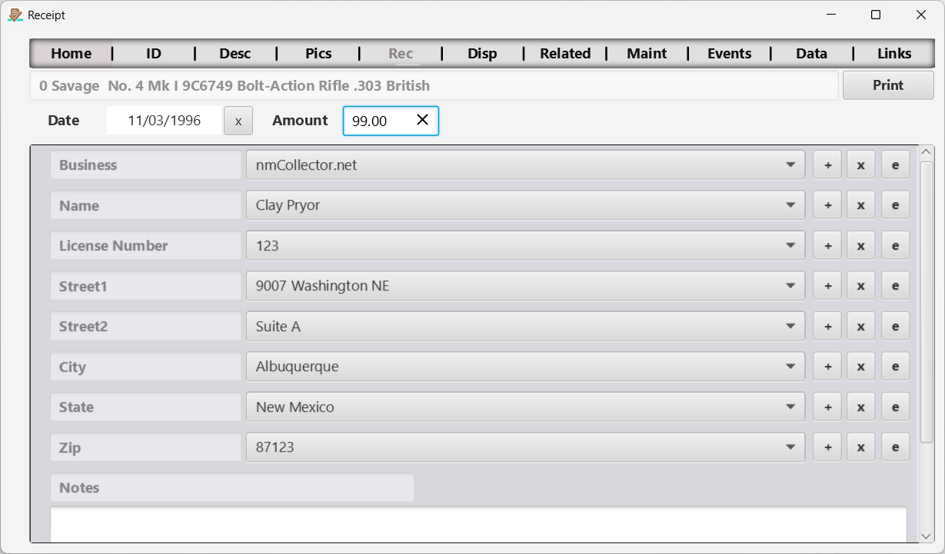
Figure 8 The Receipt page.
Capture receipt information for the selected item.
Editable text/drop-down fields support autocomplete on desktop and searchable pickers on Android and iOS. Choose or explicitly save a value using the ID Page instructions; Cancel leaves unfinished typing unsaved.

Disposition Page

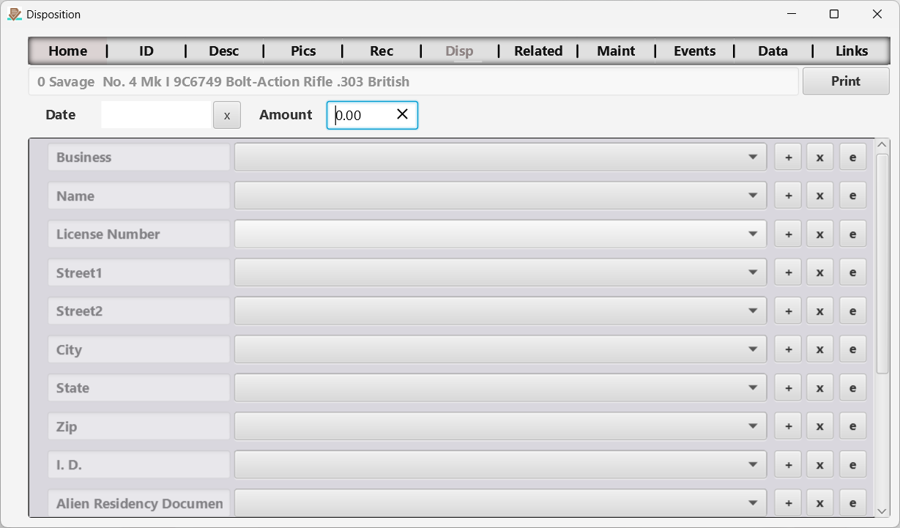
Figure 9 The Disposition page.
Capture disposition information for the selected item.
Editable text/drop-down fields support the same autocomplete and searchable-picker workflow as the ID Page. Each field uses this collection’s Disposition choices.

Related Items Page

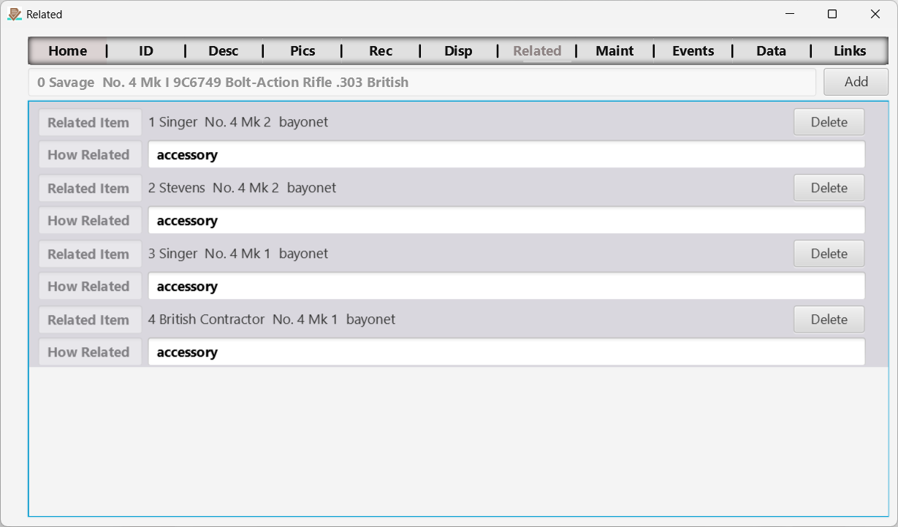
Figure 10 The Related Items page.
In some cases you may find that one item is related to one or more other items. This page allows you to capture those relationships.

Add Related Item Page

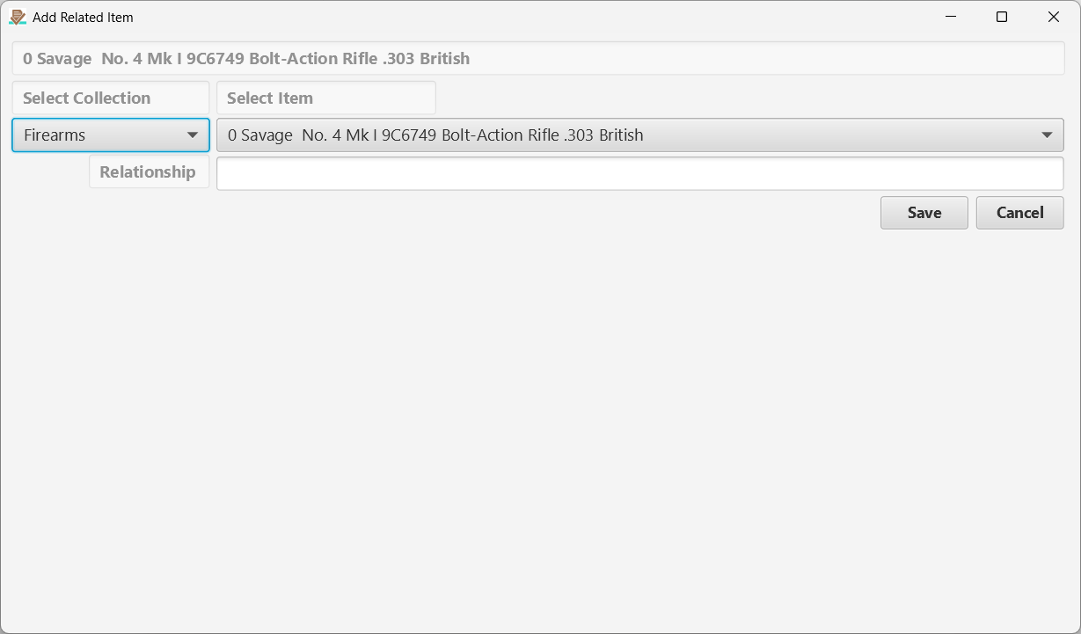
Figure 11 Add Related Item page.
Here you can specify a new related item for the selected item.

Maintenance Page

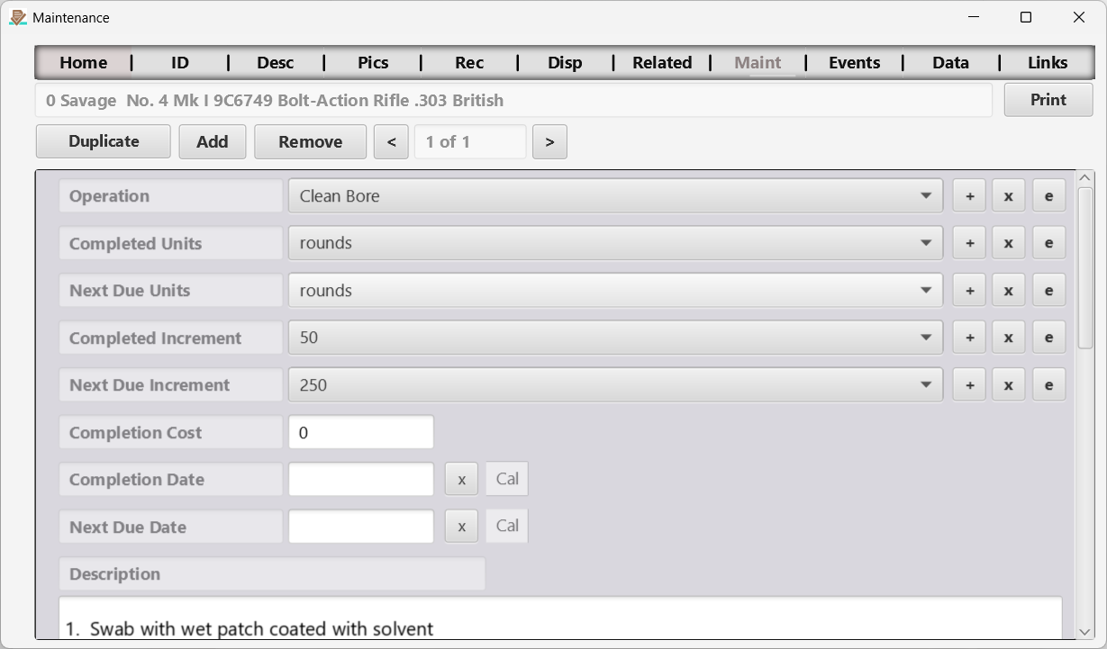
Figure 12 The Maintenance page.
Capture one or more maintenance tasks and associated data for the selected item.
Text/drop-down fields use autocomplete on desktop and searchable pickers on mobile. Select the maintenance record first, then edit its fields. Saving updates only that record; returning from the mobile picker keeps the current maintenance record selected.

Duplicate (Maintenance) Button
Use the duplicate button when you want to complete a maintenance operation. That way you do not have to re-create previously defined maintenance operations each time you repeat them.

Add (Maintenance) Button
This allows you to add a new maintenance operation with detailed tasks. Once entered the duplicate button described above can be used to capture every time the maintenance is performed.

Remove (Maintenance) Button
This will delete the current maintenance operation.

Maintenance Scroll Bar
You can scroll through maintenance records using the “<” and “>” buttons located on either side of the current maintenance record field which shows up as a number representing the current maintenance record “of” a number representing the total number of maintenance records. Maintenance records are stored in reverse chronological order so the most recent records are displayed first.

Events Page

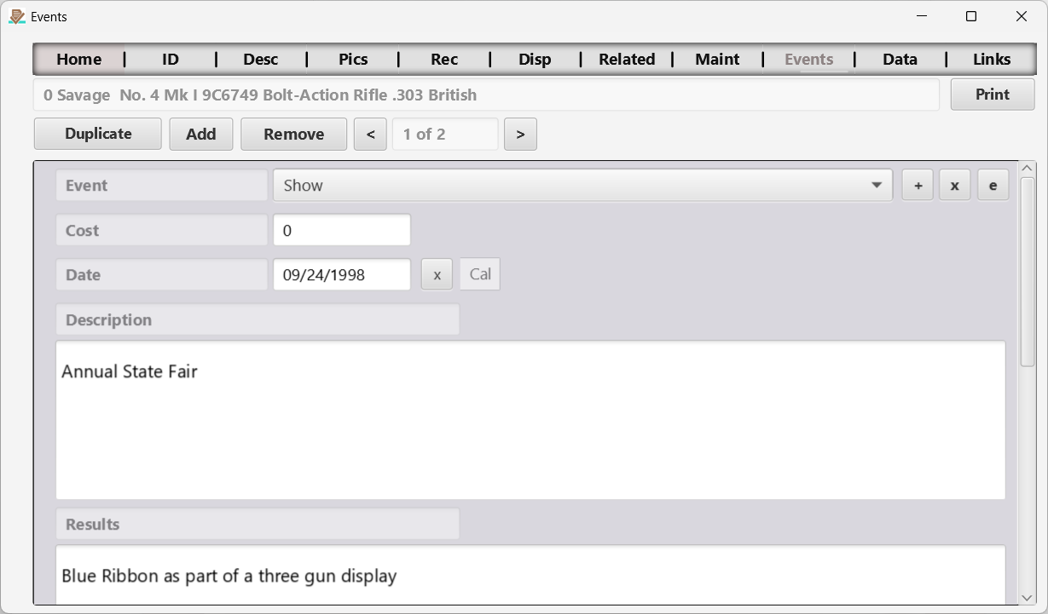
Figure 13 The Events page.
Capture one or more events and associated data for the selected item. This is essentially the same page as the Maintenance page covered earlier.
Text/drop-down fields use the same autocomplete and searchable-picker controls as Maintenance. Select the event you intend to edit before opening its fields. A saved selection belongs to that event, and returning from the mobile picker keeps it selected.

Data Sheet Page

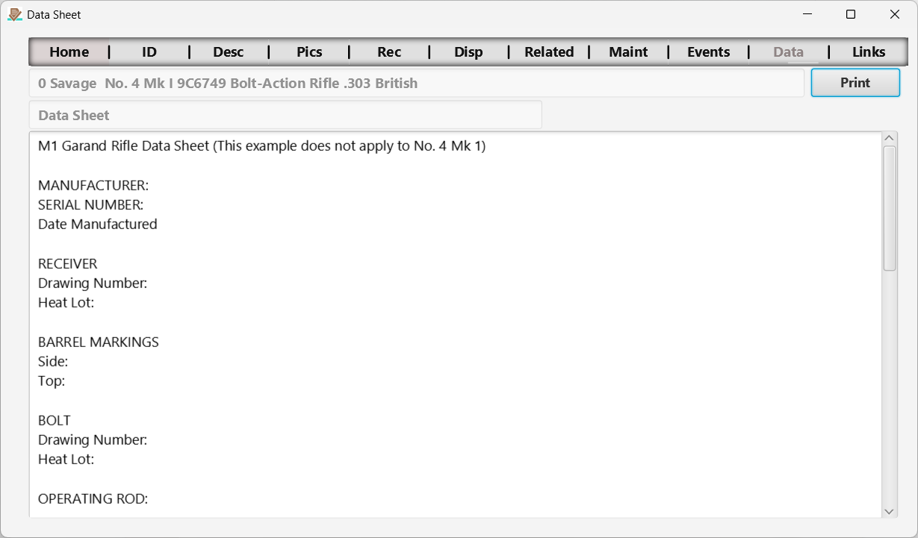
Figure 14 The Data Sheet page.
Data Sheets are a popular way to captured detailed data on components of U.S. World War II firearms which were manufactured with interchangeable parts by design. From a practical perspective, this is nothing but a really big free form field for you to enter whatever data you want.

Links Page

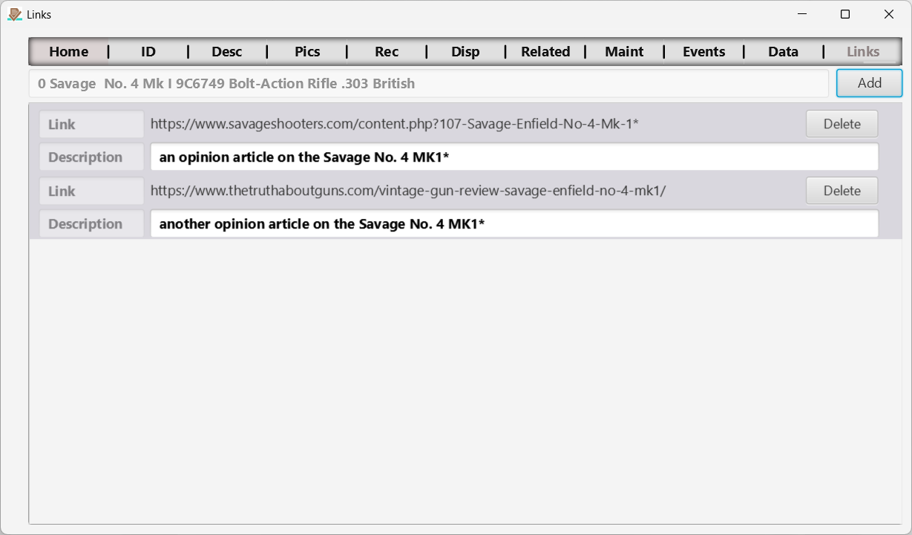
Figure 15 The Links page.
Add links to anything! This will capture whatever link you add and open the link when you click on it. You can add links to web pages, documents (including word, pdf, etc.) and even pictures.

Add (Link) Button
Navigate to any and select it. You can also drag and drop any file or web page.
Add a description if you want.

Add Link Page

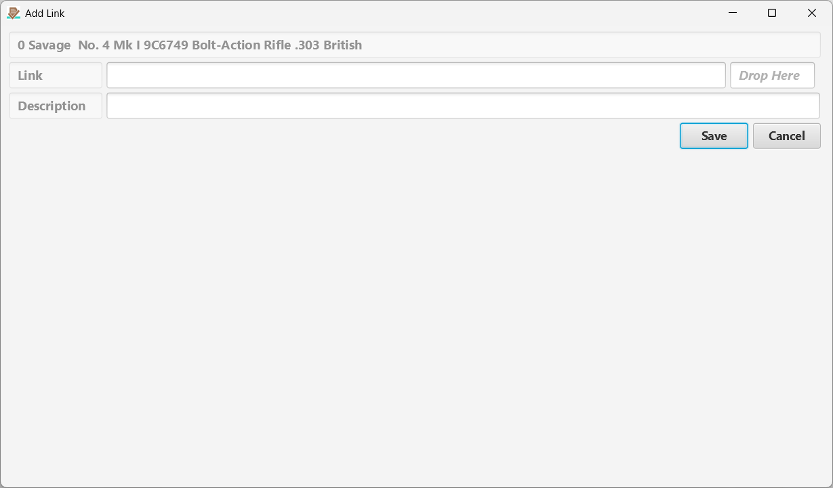
Figure 16 Add Link page.
Copy and paste or drag and drop to add a link to the currently selected item.

Drag and Drop Link
You can drag a link from anywhere and drop it in the “Drop Here” field.

Features Available Through the Menu
The menu provides many features to enhance and support general operations.
F
eatures and functionality available through the menu are described here. These do not logically fit in the general operations but are very important for configuration, data transfers, backup, and recovery.

Export Menu

When exporting data, please keep in mind that the [Help > About] menu item will open the About page (see discussion elsewhere) which will show you where the files are exported to. This location varies by operating system.
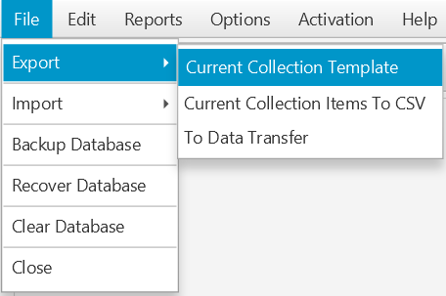
Figure 17 File > Export > …

Current Collection Template
This is how you export your collection template which defines all of the field names for a collection. This is a good way to share your collection template definitions with other users who can import your template for their own use.

Current Collection Items to CSV
You can export all of the items in the currently selected collection to a .csv file which is compatible with Excel and other spreadsheet programs. Pictures associated with each item will be stored in a pictures folder named after the item number. The item number is a behind the scenes number that you do not see in the user interface and is used to uniquely identify each item.

Export To Data Transfer
Use this feature along with From Data Transfer to copy your entire database and all of its pictures from one device to another (Windows, Mac, Linux, iOS, Android). In the mobile apps, open the Export page and tap Collection Data Transfer. The app asks which method to use:
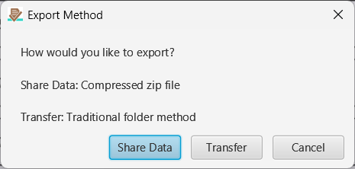
- Share Data packs the database and every picture into a single compressed file named CP_Data_Transfer.zip. On Windows, Mac and Linux, choose a folder and the zip file is written there, ready to copy to a USB flash drive, a network share or a phone. On Android and iOS, the device’s share sheet opens so you can AirDrop or Quick Share the file to another device, save it to Files, iCloud Drive or Google Drive, or send it any other way the device allows.
- Transfer writes the database and pictures to a folder named CP_Data_Transfer in the location you choose. Copy that folder to the other device. Exporting again to the same location updates the existing CP_Data_Transfer folder.
Before Share Data creates the file, the app reminds you where your data can go. The zip file is not encrypted. NM Collector CP itself never connects to the internet. If you send the file by AirDrop, Quick Share, a USB flash drive or a cable, your collection never leaves your own devices. If you send it by email or through a cloud service, it travels through that provider and is only as private as that provider makes it.
On a phone or tablet, the app checks that there is enough free space before it creates the zip file. If there is not, it tells you how much space is needed.

Import Menu

When importing data, please keep in mind that the [Help > About] menu item will open the About page (see discussion elsewhere) which will show you where files were exported to. This location varies by operating system.
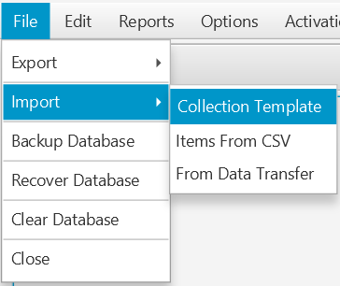
Figure 18 File > Import > …

Collection Template
This allows you to import collection definitions exported by you or others into your copy of NM Collector CP.
The template is matched to a collection by name. For example, the template file Coins_Collection.csv imports into your collection named Coins. If you do not have a collection with that name, it is created. The template’s field labels, tab labels and drop-down values are loaded in one step.
Importing a template over a collection you already have replaces its field labels with the template’s labels, tab by tab. A field the template leaves blank loses its label. Your items are not changed: their values stay in the same fields and show under the new labels. The template’s drop-down values are added to your lists, values already in your lists are kept, and values that differ only in capitalization are not added twice.
If the import would rename or remove a label that a field in your collection already has, a Field Labels Will Change message lists the affected fields before anything is written. Choose Import to continue or Cancel to leave the collection unchanged.
Before importing over a collection you use, export its template ([File > Export > Current Collection Template]) and its items ([File > Export > Current Collection Items To CSV]) so you can go back if you change your mind. To keep an existing collection as it is and load the template beside it, rename the existing collection first ([Edit > Collections]).

Items From CSV
Use this feature to import data that was exported from NM Collector CP. You can use this to transfer data from one operating system to another. This is also used along with the NM Collector JE to CP Data Migration tool to import JE data into CP.
If the items were exported from a collection whose field labels differ from yours, a Field Labels Differ message lists the differences before anything is loaded. The values show under your labels, or not at all where you have no label. Choose Import to continue or Cancel to stop.

From Data Transfer
Use this feature to load a database and pictures exported with Export To Data Transfer. In the mobile apps, open the Import page and tap Collection Data Transfer. The app asks which method to use:
- Zip File loads the CP_Data_Transfer.zip file created with Share Data.
- Folder loads the CP_Data_Transfer folder created with Transfer.
Before anything changes, the app checks that the file or folder holds an NM Collector CP transfer and makes a backup of the data already on the device. On a phone or tablet it also checks that there is enough free space. If the load cannot be completed, your previous data is put back and the app tells you so. When the load succeeds, the app asks you to restart it, and your collection, pictures included, is there when it starts again.
Importing replaces everything. A data transfer import replaces all of the data on the receiving device with the data being imported. If the receiving device holds anything you want to keep, export it first. Use the same version of NM Collector CP on both devices.

Reports Menu

Note: These are not available in mobile apps.
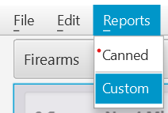
Figure 19 Reports
Selecting the Reports menu option will allow you to select Canned or Custom Reports (discussed earlier).

Backup Database Menu

Notes:
- Backup Database is not available in mobile apps. Use Data Transfer instead.
- Backup Database does not backup pictures. If you want to backup both your database and pictures use the "Export > To Data Transfer" feature instead.

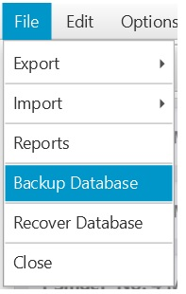
Figure 20 Backup Database
Selecting this menu option will save the database to a location that you specify. There is also an automatic backup that happens whenever you start the program. This automatic backup can be disabled in the [File > Options] menu.

Recover Database Menu

Note: Recover Database is not available in mobile apps. Use Data Transfer instead.
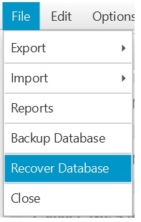
Figure 21 Recover Database
Selecting this menu option will allow you to navigate to a location where a database backup is stored so you can recover to that database. The default location that opens is where the automatic backups are stored. You can select the backup you want based on the date and time when the backup was saved. You can also navigate to a different location if you manually saved a backup. The database you select will replace your current data so choose wisely.
Note: The program will shut itself down after recovery.

Clear Database Menu
Note: Clear Database is not available in mobile apps.
Selecting [File > Clear Database] replaces your database with a fresh one that holds the twenty-nine ready-made collections and their drop-down lists, with no items. After you confirm, the app saves a copy of your current database in its data folder as nmcswDB_pre_Clear_DB_ followed by a number, and then closes. Start the app again to use the fresh database.
Export your data first if you might want any of it back. To return to the saved copy, use Recover Database and navigate to that file.

Edit Menu

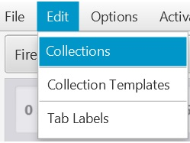
Figure 22 File > Edit > …

Edit Collections
Opens the Edit Collections Page (see below)
Deleting a collection deletes every item in it, together with its template and drop-down lists. Export the collection first if you might want it back.
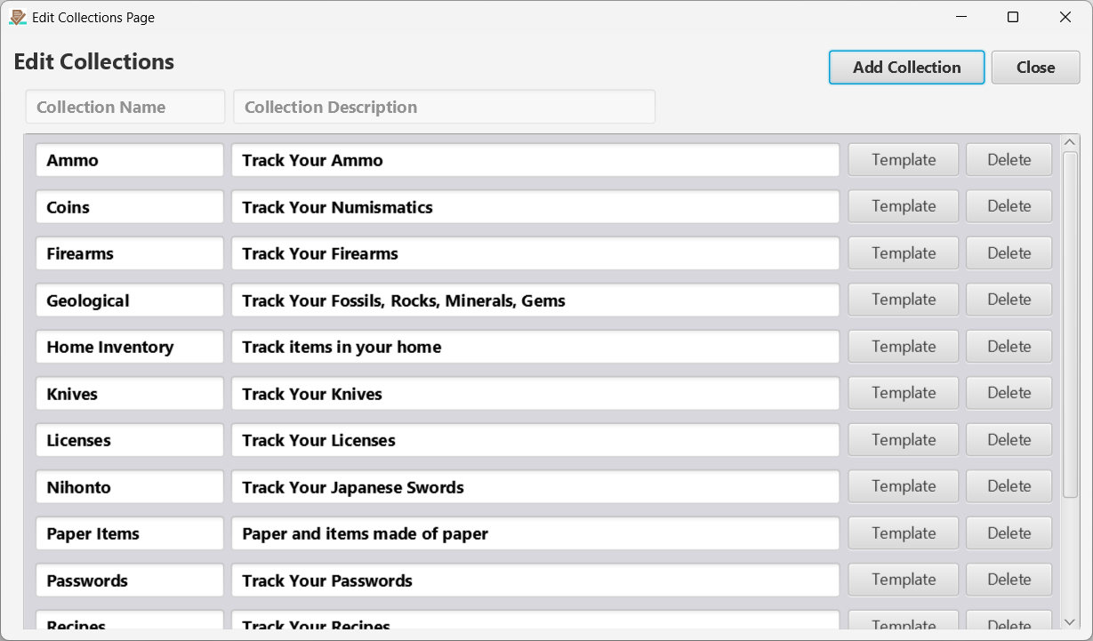
Figure 23 Edit Collections Page. Click the Template button to edit the collection template (See below)

Edit Collection Templates
Opens the Edit Template page (see below).
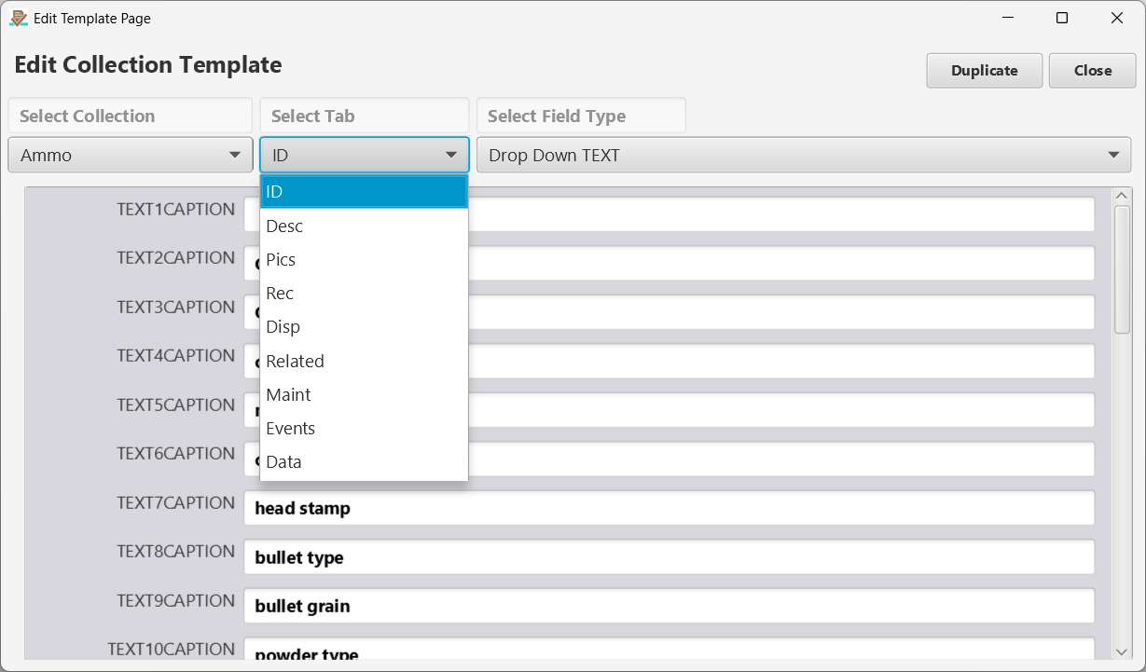
Figure 24 Edit Collection Template Page. Here you can edit any caption for any field on any tab. Remember the field types discussion above? The far right drop down allows you to select the field type that you want to edit the captions for.

Edit Tab Labels
You do not like the current tab labels? You can change them to whatever you want here. Keep them short so they fit in the tabs!
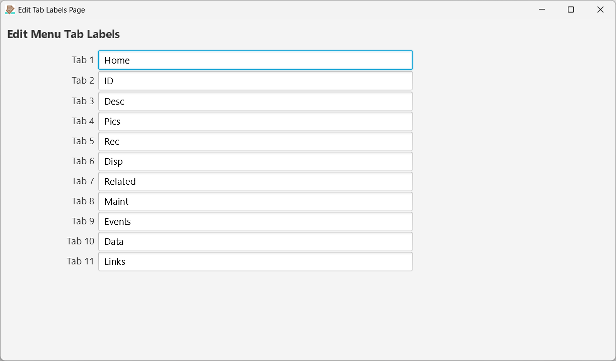
Figure 25 Edit Tab Labels.

Options Enable/Disable Backups
Automatic backups are enabled by default but they can be disabled through this menu option. After they have been disabled you can go back here to enable them.
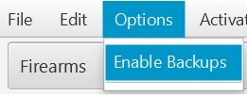
Figure 26 Options > Enable/Disable Backups.

Activation Menu
Here you can [View] the status of your activation, open the eCommerce site to [Purchase] an activation, and [Apply] a purchased activation after you have downloaded it from the activation email you will receive after purchase. If a new activation is applied, the activation file will be loaded and the expiration date will be updated to match the current subscription.
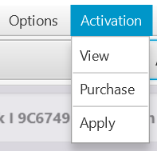
Figure 27 Activation.

Help > About Menu

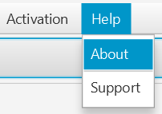
Figure 28 Help Menu options.

About Page
This is a very useful page when you are trying to figure out where certain files exist on your system. One of the most important ones is the Exports directory. This is where you go to find exported data.
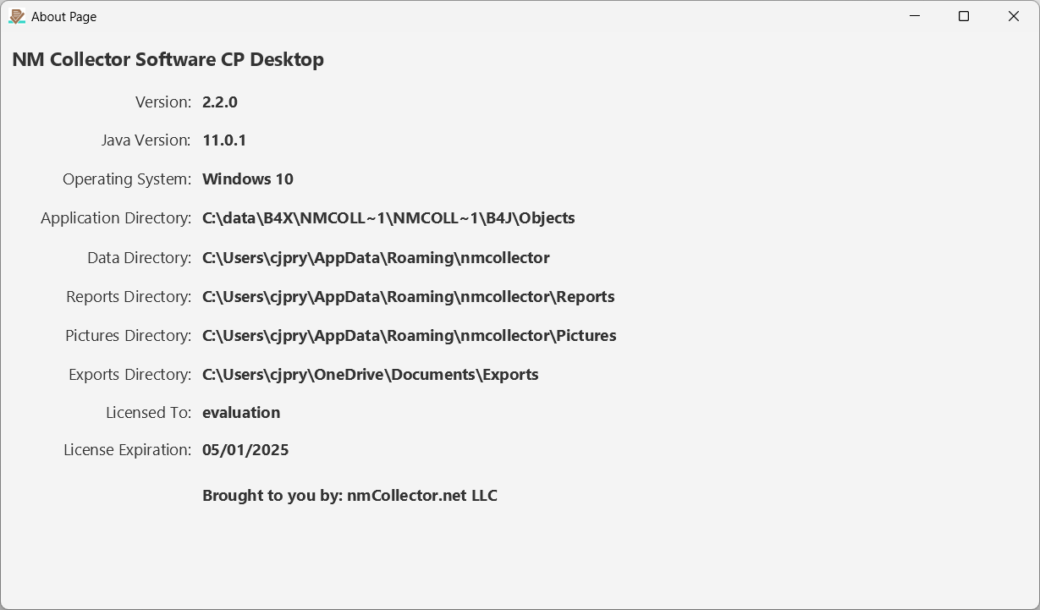
Figure 29 About Page.

Support
Opens the NM Collector CP support site, www.nmcollector.net/support.

Companion Apps

General
Companion mobile apps are available for both Android and iOS devices. File management tools on these devices can be used to transfer data to and from the desktop applications and between devices.
- Searchable field choices. Across Identification, Description, Receipt, Disposition, Pictures metadata, Maintenance and Events, tap an editable field to browse or search its choices. Tap a result to save, tap Use new value to add an entry, or Cancel to leave the original unchanged. Keyboard Done only dismisses the keyboard. Detailed steps appear under Autocomplete and searchable choices in the ID Page section.
- Data transfer. On the Export and Import pages, tap Collection Data Transfer to move your whole collection, pictures included, between devices. See Export To Data Transfer and From Data Transfer.
- Templates and CSV files. Collection templates and item CSV files can be exported and imported on the Export and Import pages. See Import Menu for how a template import treats a collection you already have.
- Help. Help/About shows the installed version, and Help Link opens www.nmcollector.net/support.
Printing: on Android, the Print button opens a chooser so you can send the report to Gmail, Google Drive or any other app. On iOS, save the report to your file system and then open it from the Files app.

iOS
The iOS app conforms to Apple standards for iOS apps so it should feel familiar to iOS users. Special considerations for the iOS app include the following:
On iPhone and iPad, the searchable picker adjusts to the screen, safe areas and on-screen keyboard. Select a result or tap Use new value to save; use Cancel or navigation Back to leave the current value unchanged.
- The iOS app requires iOS 16 or later.
- Share Data uses the iOS share sheet and Zip File import uses the Files app, so you can use AirDrop, the Files app and iCloud Drive to move a transfer between devices.
- Transfer and Folder open the iOS folder picker, so you can export to and import from On My iPhone, iCloud Drive, a connected USB drive or a network share.
- Template and CSV exports are saved to the app’s Exports folder, and template and CSV imports pick from it. In the Files app this is On My iPhone (or On My iPad) > nmCollectorCP > Exports. To import a template or CSV file from another system, copy its files into that folder first.
- Before a share or an import, the app checks that there is enough free space and tells you how much is needed if there is not.
- Help/About also shows the privacy policy.
- iCloud Drive is a convenient way to move files between the desktop application and the iOS app.

Android
The Android app conforms to Android standards for Android apps so it should feel familiar to Android users. Special considerations for the Android app include the following:
On Android phones and tablets, editable field values open the searchable picker. Back may hide the keyboard first; Cancel or a further Back press leaves the picker without saving typed text. Tap a result or Use new value to save.
- The Android app requires Android 5.0 or later.
- Share Data uses the Android share sheet, so you can Quick Share the zip file to another phone, save it to Google Drive or Downloads, or attach it to an email. Zip File import lists every file, so a zip received by email, Google Drive or Quick Share can always be selected. A file that is not a transfer is refused.
- For template, CSV and folder transfers, you select the folder to export to or import from. Exporting again to the same folder replaces the earlier files.
- Use the Android File Manager to access external folders.
- You can use the Windows File Manager to copy files to and from your Android device.
- The app stays in portrait orientation on phones and tablets, and the Back button returns to the previous page.

NM Collector CP Software Version History

Version 2.3 Released October 2026
- Autocomplete in editable drop-down fields on Windows, Mac and Linux; searchable pickers on Android and iOS.
- Share Data: export the database and all pictures as one zip file. Zip File import, with a backup and automatic restore if the import fails.
- Folder transfers on iOS use the iOS folder picker.
- Twenty-nine ready-made collections, sixteen of them new, each with three sample items. Twelve existing templates refreshed with larger drop-down lists.
- Template import matches collections by name and warns before field labels change. Items From CSV warns when field labels differ.
- Template and CSV imports on Android and iOS.
- Android 16 support and report sharing on Android. iOS 16 or later required; iPad share and file picker fixes.
- Clear Database starts from the twenty-nine ready-made collections.
- Bug fixes: apostrophes and one- and two-character values are saved as typed; deleting an item or a collection removes all of its records; cancelling a folder chooser cancels the operation; window placement across monitors; startup with a damaged window settings file; database locked after renaming a collection.

Version 2.2 Released April 2023

Bug Fixes
- When a custom report is created and stored in the reports directory, it does not show up in the available canned reports dropdown menu.
- If opened last on an external monitor the window location is saved to re-open on that monitor. If the external monitor is disconnected and the program is re-opened without the external montor, the main screen is not visible because it loads in the location of the external monitor that is no longer present.
- When a link with a file name that contains spaces is clicked the file does not open.

Enhancements
- Added Export (to .csv) button to Stats Page.
- Added Export (to .csv) button to Custom Reports.
- Allow selection of Export Dir for all exports.

Version 2.1 Released March 2023
- Simplified transfer of data between platforms.
- Automatically convert existing 10 year activations to lifetime activations.

Version 2.0 Released November 2021
- Simplified addition of new item data for large collections
- Custom (Dynamically generated) Reports
- Print Page Reports
- Fixed JE import missing pictures

Version 1.0 Released October 2021
- Activation

Version 0.7 Released October 2021
- Events Tab
- Maintenance Tab
- Links Tab (including capture of PDFs)
- Statistics Page

Version 0.6 Released September 2021
- Move item from one collection to another
- Ensure sort order of JE exported pictures is retained when imported into CP
- Related Items Tab
- Export/Import Data
- Export Collection Template
- Import Collection Template
- Duplicate Template

Version 0.5 Released August 2021
- Automated Backup (with recovery option) – can be enabled/disabled
- Better manage file selection (restrict to valid options, remember paths)
- Remember last selected collection for next time application is started
- Fix Linux bugs related to usage of File System
- Edit Tab Labels
- Edit Collections
- Edit Template Captions
- Duplicate Item
- [Help > About] with key information for support
- Set last collection viewed to open by default
- Clear Disposition in case entered by accident

Version 0.4 Released July 2021
- Canned Reports
- Datasheet Tab
- Import from JE (ID, Description, Receipt, Disposition, Pictures, Data Sheets)
- Increase width of Add Pictures button on Linux
- Performance improvements for large volumes of data

Version 0.3 Released July 2021
- Manage Pictures

Version 0.2 Released June 2021
- Add and Delete Items
- Filter (search) items in the list
- Change the sort of items in the list
- Add to drop down lists (DDLs) values
- Identification information
- Description information
- Receipt
- Disposition

Version 0.1 Released May 2021
- Technology and general architecture proof of concept.

